Students: Andrew-Nicholas Rusu, Luca Szilvassy Rosas, Mathias Lynch
Teacher: Reza Mirsalari
Date: October 2nd, 2026
Class: Java Web Development

Java Web Assignment 4 Report on Medical
Supply Inventory Management System
- Spring Initializr/project configuration:
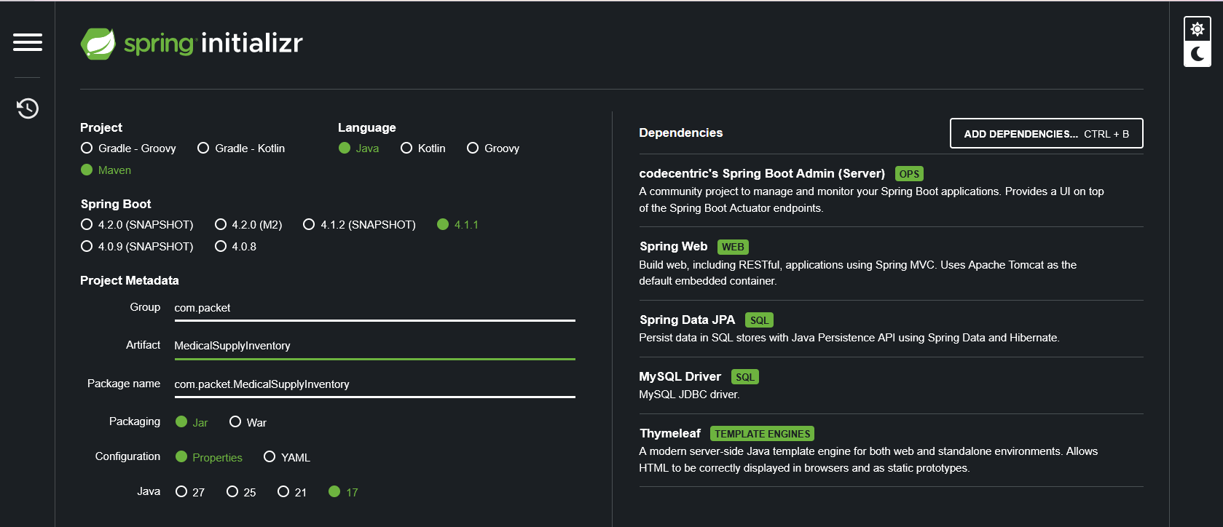

- Project structure:
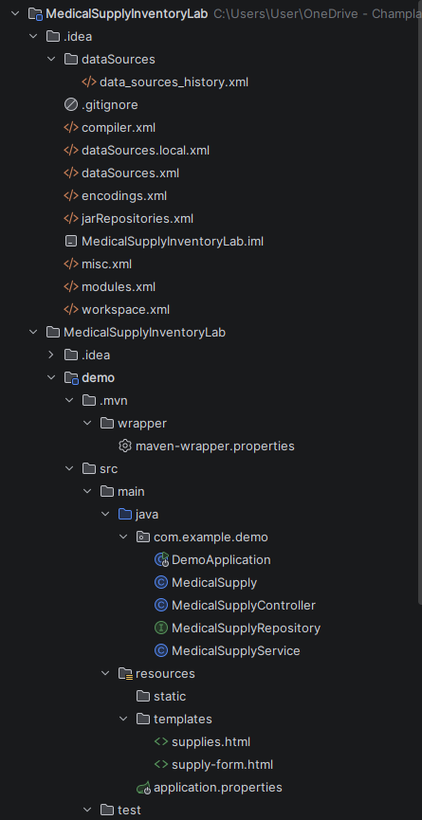
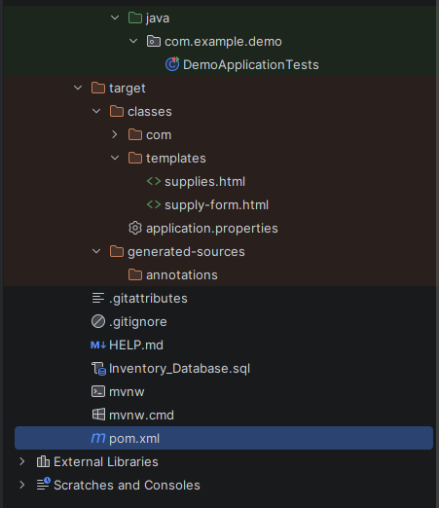

- Required Maven dependencies:
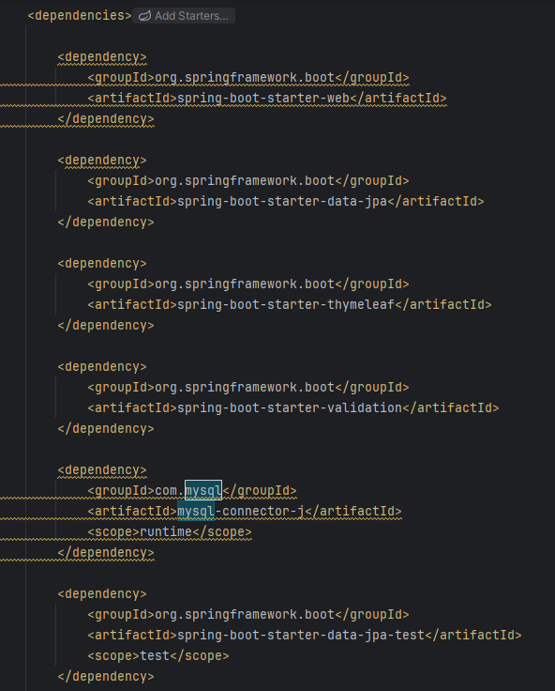
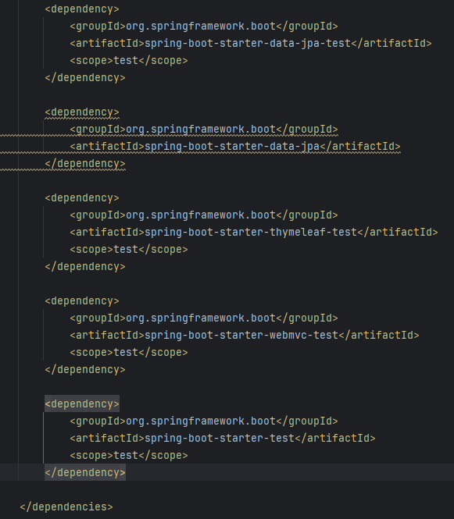

- MySQL schema and medical_supply table:
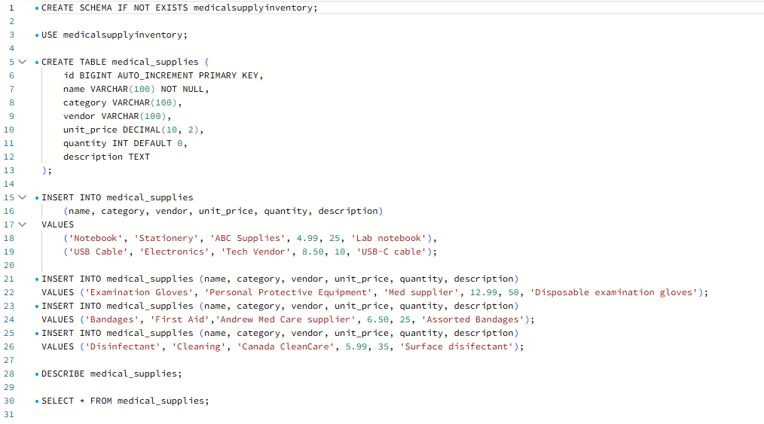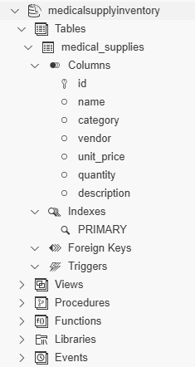
- Database connection configuration:
- MedicalSupply entity:
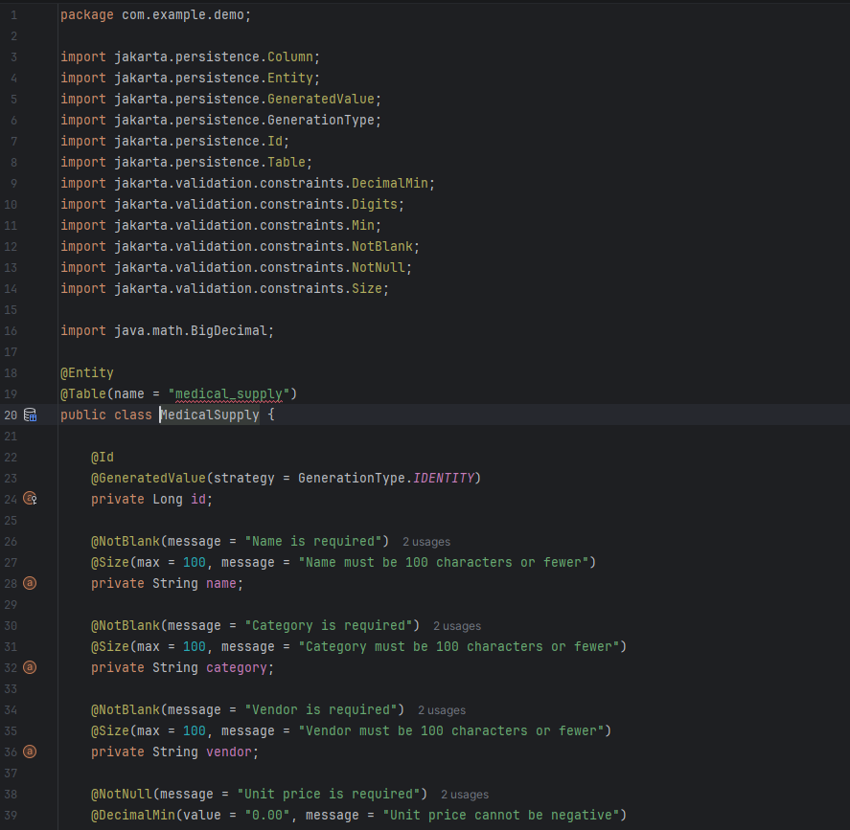
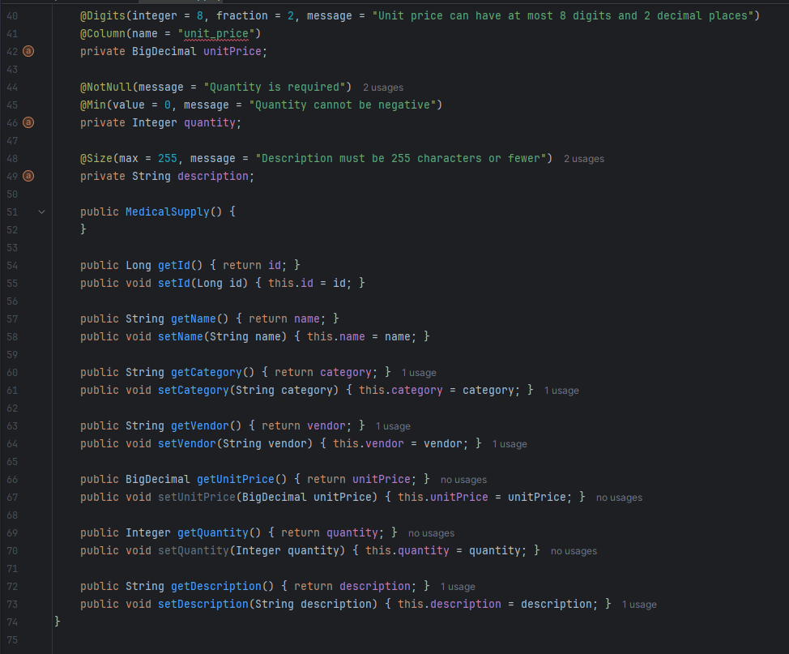
- Repository/DAO:
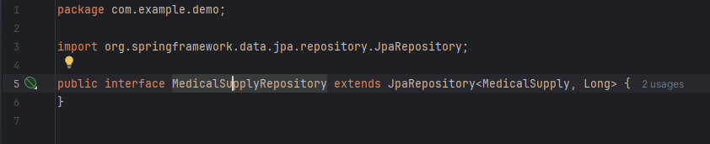

- Service:
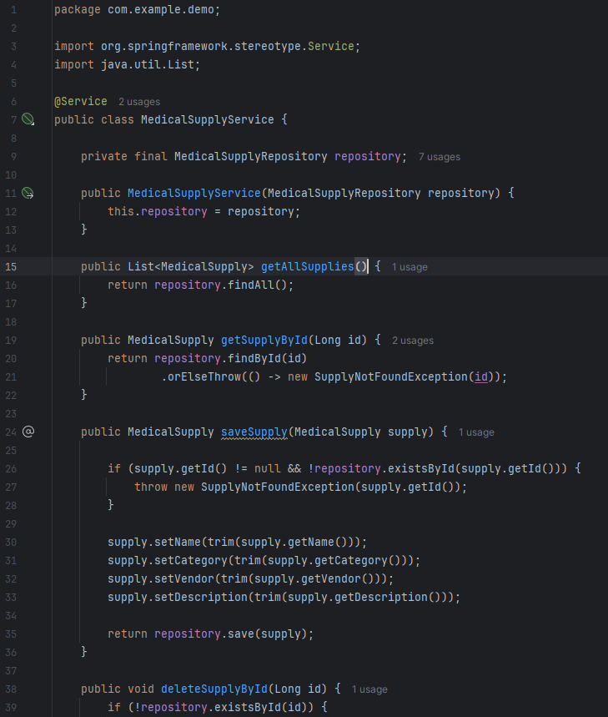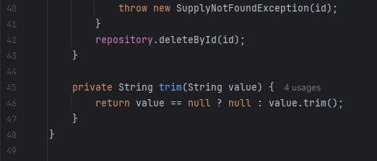
- Controller:
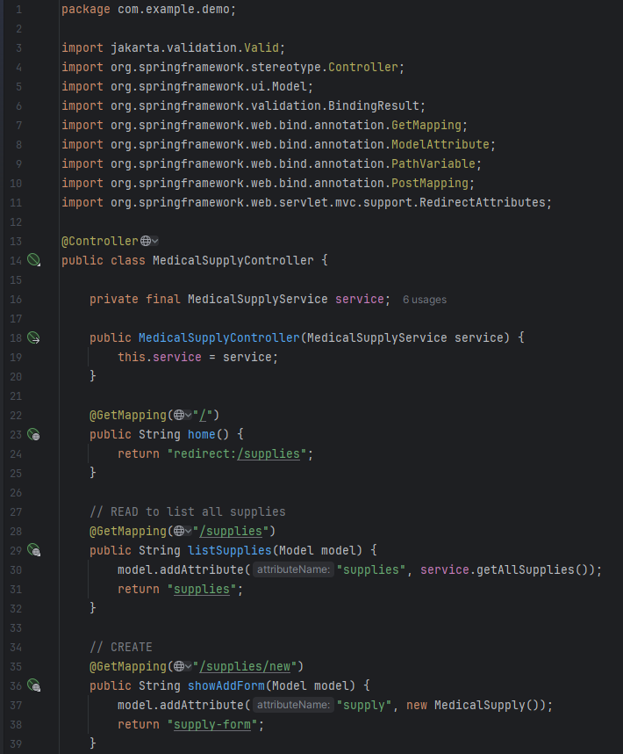

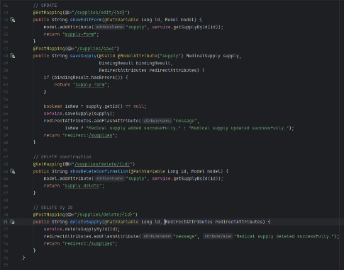
- Thymeleaf templates:

- Running inventory page:
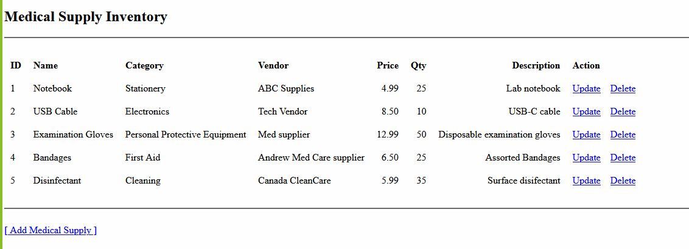
- Create operation:

- Read operation:
- Update operation:
- Delete operation:
- MySQL Workbench evidence showing database changes:

